**MONGODB TASK 2**

Design Database for zen class Programmme

**Create database for Guvi_users:**

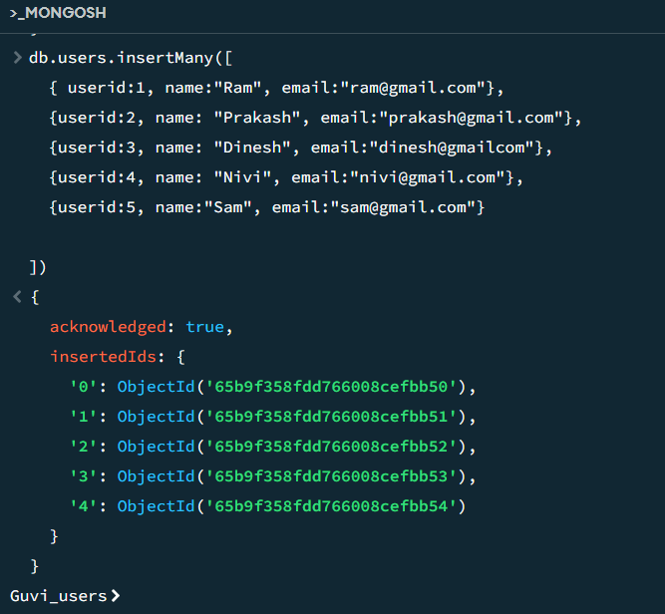

db.users.insertMany([

{ userid:1, name:"Ram", email:"ram@gmail.com"},

{userid:2, name: "Prakash", email:"prakash@gmail.com"},

{userid:3, name: "Dinesh", email:"dinesh@gmailcom"},

{userid:4, name: "Nivi", email:"nivi@gmail.com"},

{userid:5, name:"Sam", email:"sam@gmail.com"}

])

**Create collection and insert data :”Codekata”**

db.codekata.insertMany([

{userid:1, problems:50},

{userid:2, problems:60},

{userid:3, problems:90},

{userid:4, problems:70},

{userid:5, problems:80}

])

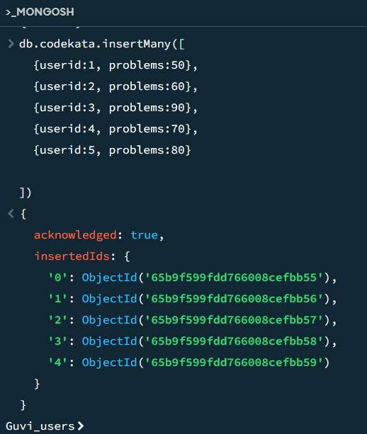

**Create collection and insert data :”Attendance”**

db.attendance.insertMany([

{userid:1, topicid:2, attended: true},

{userid:2, topicid:1, attended:true},

{userid:3, topicid:5, attended:true},

{userid:4, topicid:3, attended:true},

{userid:5, topicid:4, attended:false}

])

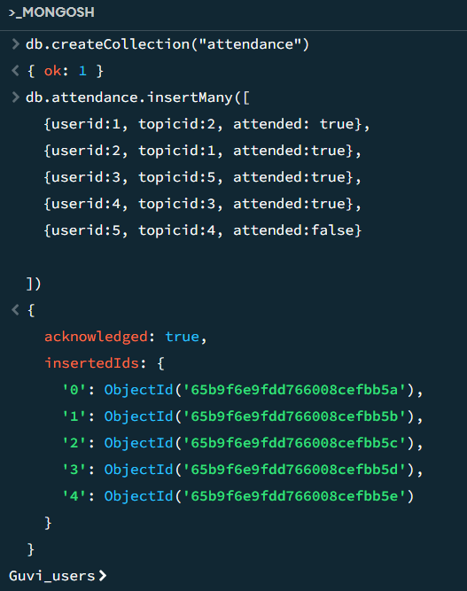

**Create collection and insert data: “Topics”**

db.topics.insertMany([

{topicid:1, topic:"HTML", topic_date: new Date("18-Oct-2020")},

{topicid:2, topic:"CSS", topic_date: new Date("28-Jan-2020")},

{topicid:3, topic:"Javascript", topic_date: new Date("05-Nov-2020")},

{topicid:4, topic:"ReactJs", topic_date: new Date("14-Dec-2020")},

{topicid:5, topic:"NodeJs", topic_date: new Date("25-sep-2020")}

])

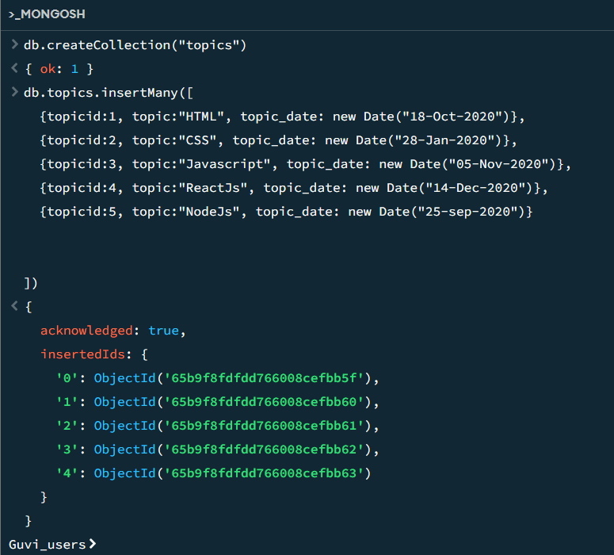

**Create collection and insert data: “Tasks”**

db.tasks.insertMany([

{taskid:1, topicid:1, userid:1, task:"HTML Task", due_date: new Date("18-Oct-2020"), submitted: true},

{taskid:2, topicid:2, userid:2, task:"CSS Task", due_date: new Date("28-Oct-2020"), submitted: false},

{taskid:3, topicid:3, userid:3, task:"Javascript", due_date: new Date("05-Nov-2020"), submitted: true},

{taskid:4, topicid:4, userid:4, task: "ReactJs", due_date: new Date("15-Nov-2020"), submitted:true},

{taskid:5, topicid:5, userid:5, task:"NodeJS", due_date: new Date("25-Nov-2020"), submitted: false}

])

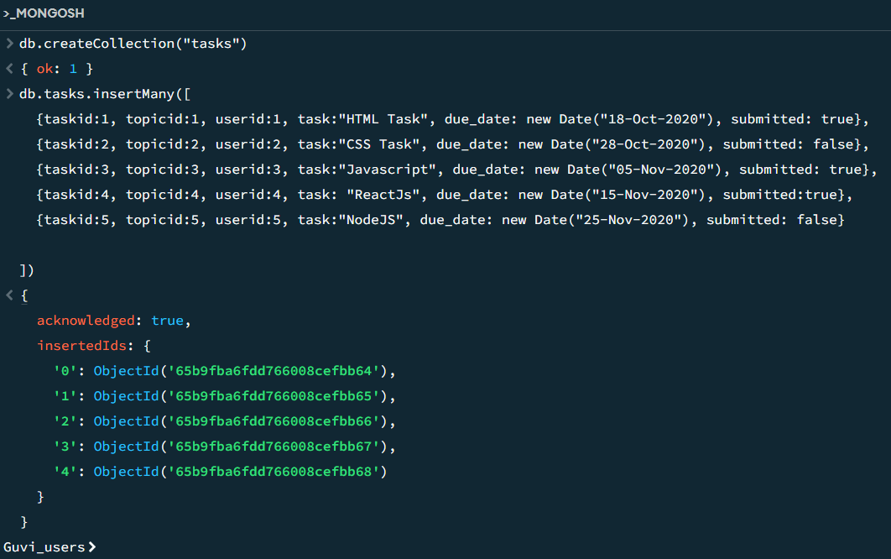

**Create collection and insert data:”CompanyDrives”**

db.companydrives.insertMany([

{userid:1, drive_date: new Date("20-Oct-2020"), company:"Apple"},

{userid:2, drive_date: new Date("22-oct-2020"), company:"Amazon"},

{userid:3, drive_date: new Date("25-Oct-2020"), company:"Flipkart"},

{userid:4, drive_date: new Date("30-Oct_2020"), company: "Zoho"},

{userid:5, drive_date: new Date("05-Nov_2020"), company: "CTS"}

])

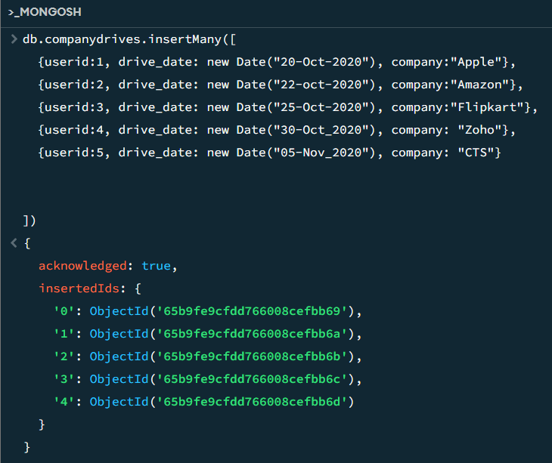

**Create collections and insert data:”Mentors”**

db.mentors.insertMany([

{mentorid:1, mentorname: "Rupan", mentor_email: "rupan@gmail.com", mentee_count: 20},

{mentorid:2, mentorname:"Nagarajan", mentor_email: "naga@gmail.com", mentee_count: 18},

{mentorid:3, mentorname:"Subha",mentor_email: "subha@gmail.com", mentee_count: 30 },

{mentorid:4, mentorname:"Manoj", mentor_email:"manoj@gmail.com", mentee_count:15},

{mentorid:5, mentorname:"krisha", mentor_email:"kri@gmail.com",mentee_count:20}

])

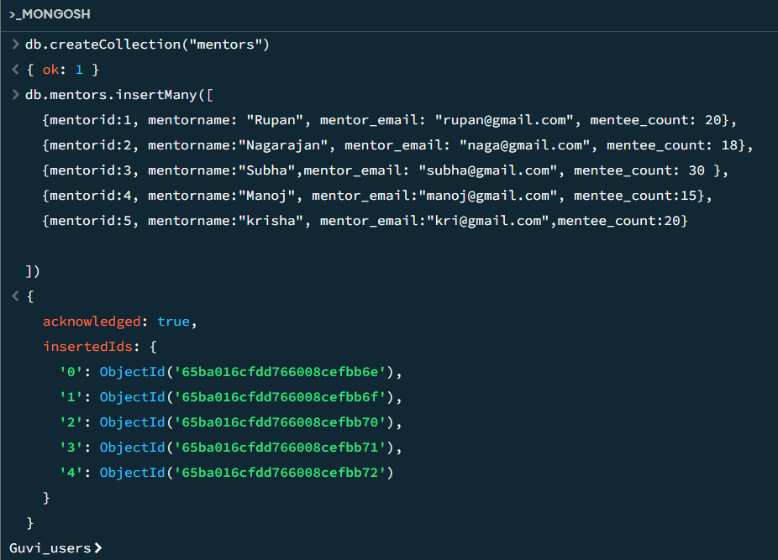

CREATED DATABASE

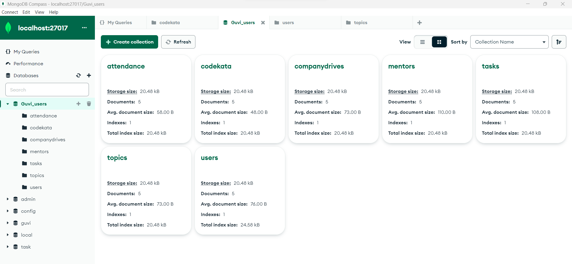

**Task Solutions:**

1.Find all the topics and tasks which are thought in the month of October:

db.topics.aggregate([

{

$lookup: {

from: "tasks",

localField: "topicid",

foreignField: "topicid",

as: "taskinfo"

}

},

{

$match: {

$and: [

{ topic_date: { $gte: new Date("2020-10-01"), $lt: new Date("2020-11-01") } },

{

$or: [

{ "taskinfo.due_date": { $gte: new Date("2020-10-01"), $lt: new Date("2020-11-01") } },

{ "taskinfo.due_date": { $exists: false } }

]

}

]

}

},

{

$project: {

_id: 0,

topicid: 1,

topic: 1,

topic_date: 1,

tasks: "$taskinfo.task",

due_dates: "$taskinfo.due_date"

}

}

])

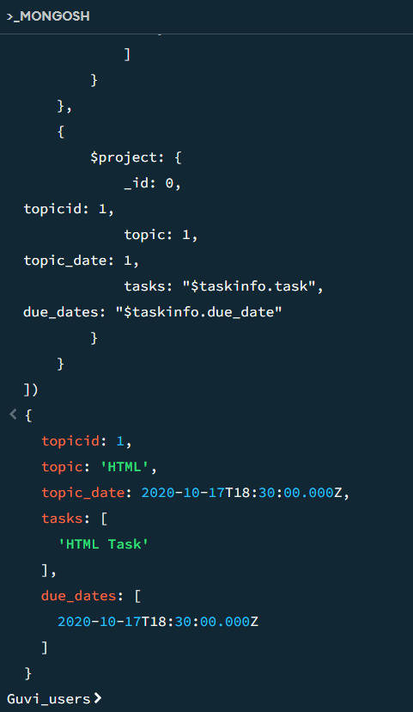

2. Find all the company drives which appeared between 15 oct-2020 and 31-oct-2020

db.companydrives.find({

$or:[

{drive_date: {$gte: new Date("15-oct-2020")}},

{drive_date: {$lte: new Date("31-oct-2020")}}

]})

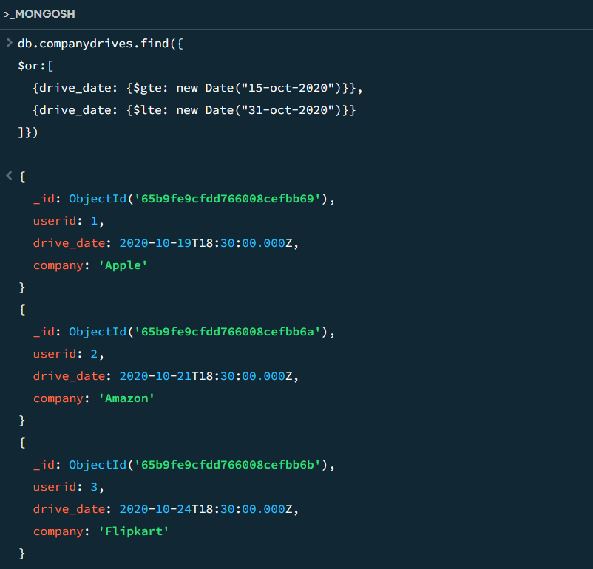

3. Find all the company drives and students who are appeared for the placement.

db.companydrives.aggregate([

{

$lookup:{

from:"users",

localField:"userid",

foreignField:"userid",

as: "userinfo"

}

},

{

$project:{

_id:0,

company:1,

drive_date:1,

students:"$userinfo"}}

])

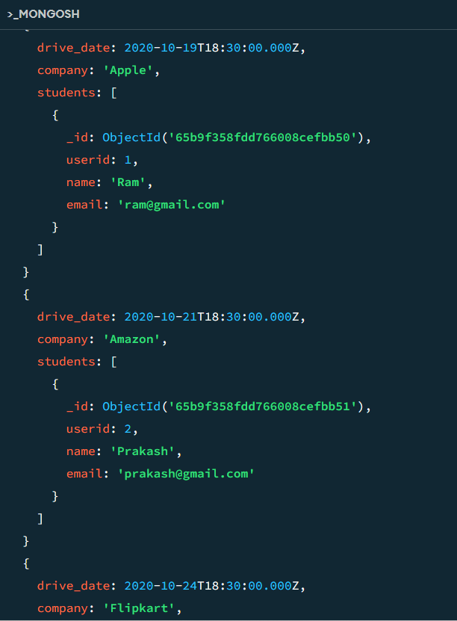

4. Find the number of problems solved by the user in codekata:

db.codekata.aggregate([

{

$lookup:{

from:"users",

localField:"userid",

foreignField:"userid",

as:"userinfo"

}},

{

$group:{

_id:{

userid:"$userid",

username:"$userinfo.name"

},

total_problems_solved:{$sum: "$problems"}

}},

{

$project:{

_id:0,

userid:"$_id:userid",

username:"$_id.username",

total_problems_solved:1

}}])  
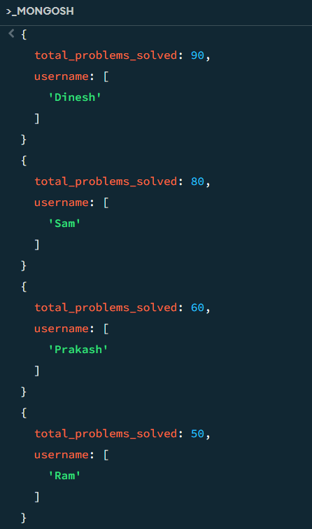

5. Find all the mentors with who has the mentee's count more than 15

db.users.aggregate([

{

$match:{mentorid:{$exists:true}}

},

{

$group:{

_id:"$mentorid",

mentorname:{$first: "$mentorname"},

mentee_count:{$sum:1}

}},

{

$match:{mentee_count:{$gt:15}}

},

{

$project:{

_id:0,

mentorid:"$_id",

mentorname:1,

mentor_count:1}}

])

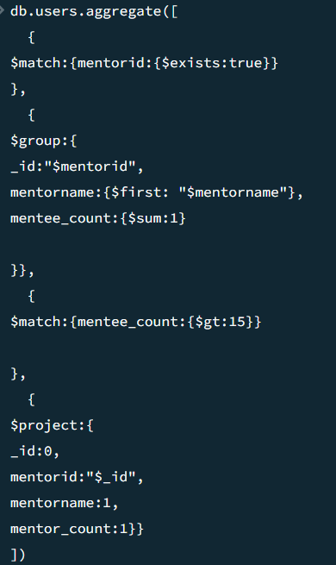

1. Find the number of users who are absent and task is not submitted  between 15 oct-2020 and 31-oct-2020

